**INTERVIEW QUESTION BANK**

**(Krima) AMAZON CODE CHALLENGE:**

1. **Sliding WIndow Sum**: Given a list of integers and a window size, return a new list of integers where each integer is the sum of all integers in the kth window of the input list. The kth window of the input list is the integers from index k to index k + window size - 1(inclusive). For example, [1, 2, 3, 4] and window size 3 should return [6,9].
2. **Overlap Rectangles:** Given two rectangles, find if the given two rectangles overlap or not.
3. **Busiest Node in a Graph**: Given a manager employee hierarchy  as a graph with nodes and edges of a company along with their tenures as weights of the node, find the manages whose team has maximum average tenure.

**(Krima) VMware CODE CHALLENGE:**

1. **Songs in a playlist** : I think this was a tree problem. Find the shortest way to search a song in a playlist.
2. **Print all possible combinations of given digits**: its a permutation question where you have to print all possible permutations of a given string of digits For eg. 123 all possible combinations are 3! = 6  - 123,132,213,231,312,321
3. **chooseFleets:** There are fleet of ships with only two kinds - one with capacity of 2 ppl and another with capacity of 4 ppl. Given a number of people and fleet of ships find the minimum number of ships required to transport the ships.

**(Preethi) Accompany Phone screen 1**

1. group anagrams (leetcode question)
2. 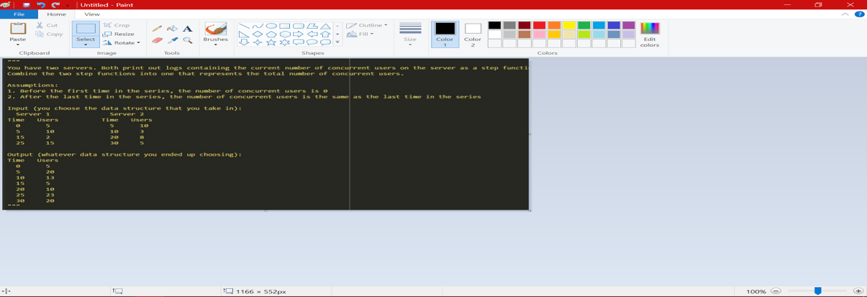

**(Preethi) Accompany Phone Screen 2**

1. Given an MX N matrix in which each row and each column is sorted in ascending order, write a method to find an element. (CTCI 11.6)
2. Discussion - build a spam filter for emails

**(Preethi) Aetion coding challenge**

1. Given an array, find the smallest possible distance between two distinct elements (index wise. i.e. if there are 2 7’s in the array, they are considered distinct)
2. given non-empty array. you can perform single swap function. goal is to check if array can be sorted in non-decreasing order by performing at most 1 swap operation. return boolean
3. arithmetic slices (lc question)

**(Preethi) BuildZoom Phone 1**

1. Given a boolean 2D array with one rectangle, find upper-left corner, width and height of that rectangle
2. Given a boolean 2D array with multiple rectangles, find all upper-left corners, widths and heights

**(Preethi) BuildZoom Phone 2**

1. discussion - build recommendation engine

**(Preethi) LiveRamp coding challenge**

1. Given 4 digits, find the max possible time that can be displayed on digital clock in 24 hour format. Ex: given 1,8,3,2, max digital time is 23:18. If not possible to determine maximum, return “NOT POSSIBLE”. ex: given 9,1,9,7, return “NOT POSSIBLE”
2. minimum len unsorted subarray (<http://www.geeksforgeeks.org/minimum-length-unsorted-subarray-sorting-which-makes-the-complete-array-sorted/>)

**(Preethi) Lucid Software coding challenge**

1. Find the length of the longest of a special sub‐sequence as defined below through adjacent, non‐repeating cells ﴾including diagonals﴿ in a rectangular grid of numbers. The special subsequence is defined such that the difference between the current and next value in the subsequence is greater than 3.For example, in the following grid, one legal path ﴾though not the longest﴿ that can be traced is 0>6>2>8 and its length is 4.

8 2 4

0 6 1

3 7 9

**(Preethi) Lucid Software phone interview**

1. Sort this array by the length of the string, then alphabetical order (case- insensitive).  For example, a correctly sorted list might be:

a

D

z

vb

afd

1. Write a small, reasonably efficient class that takes strings as input, and calls a callback method whenever a newline ("\n") is reached, passing in the previous line's text. The class should discard old data when possible to save memory.
2. Implement the board game Othello/Reversi on the following board. Alternate black and white turns, and don't allow illegal moves (a bunch of code was already given, just had to fill in logic)

**(Preethi) Yelp coding challenge**

1. We have two list of businesses obtained from two different services namely “Trendy Businesses” and “Favorite Businesses”. Each list is sorted by their number of reviews in descending order. We would like to build a tool, that obtains both the list and aggregates them displaying all businesses in sorted order based on number of reviews.

Example:

Input:

2 3

100 1000

103 900

203 950

201 800

202 700

Output:

100 1000

203 950

103 900

201 800

202 700

**(Preethi) Bloomberg Phone**

1. valid BST (leetcode question)
2. next successor in BST (leetcode question. see CTCI for good explanation and optimized solution)

**(Preethi) Bloomberg Onsite**

Data structure rapid round

1.       Search/insert time in array

2.       Search/insert time in linked list

a.       What if you had a slow/fast pointer

3.       Search/insert time in a trie

Ways of implementing

How to make it faster

4.       Search/insert time in BST

5.       Search/insert time in binary tree

OS questions

1.       Process vs. thread

2.       Does a thread share space with its process? Which part, specifically?

3.       Statically typed vs. dynamically typed languages

a.       Why are dynamically typed languages such as python gaining popularity

4.       Don’t remember exact question but something to do with mutex and semaphores

5.       Different data types (string, int, array) …what part of memory does it occupy (stack or heap)

6.       When you create a new object in java… how is everything allocated in memory?

7.       When you’re done using an object, how is that memory regained?

Asked to code

1.       Given a string of only upper case letters, sort its letters by frequency and in alphabetic order in the case of a tie, for example BLOOMBERG -> BBOOEGLMR

2.       Find the largest 2 numbers in a stream of integers

3.       Find the largest k numbers in a stream of integers (Best time complexity: Nlgk)

4.       Implement binary search

**(Preethi) Yahoo phone**

An app developer is building a new app in  iOs. The app is not open to public and is currently in a stealth mode and can only be used if you have any recommendation by any of the existing users of the app. Once a user registers in the App he can recommend only 2 users. After launching the app into iOs, the developer sends 2 recommendation to his friends. Within days the app had thousands of users. He wants to find out those users which were farthest in the link of recommendations from him.

follow up - what if we’re interested in people who haven’t recommended to anybody? find those people

**(Preethi) Yahoo Onsite**

Round 1

Started off by asking how to determine if linked list is a palindrome, I explained how that can be done. In the end, just asked me to code how to reverse a linked list.

Design a DDL schema in DB where you model class enrollment system in a college. ex: you can have table for student, professors, courses offered etc. you need to have a table that contains info on which prof is teaching which course for a given quarter.

the table should also consider a constraint - you cannot have rows in the table that indicate a professor is teaching two classes that take place at the same time

Round 2

Given a number N, output all the numbers, x, between 0 and N such that x is the biggest number among all the permutations of x. Optimize 3 times

Ex: say x = 934. There’s a permutation of 934 that is bigger than 934 (i.e. 943). Therefore, do not print 934.

Round 3

Robot hand movement

Given a (1) string message (consisting of only upper case alphabets), and (2) width of keyboard, output the movements required by an automated robot hand to print out the string message.

The robot hand can move right, left, up or down. It cannot move diagonally.

Ex 1:

String message: “HI”

Width: 26

Output: R8, T, R1, T

Ex2:

String message: “HELLO”

Width: 13

Output: R8, T, L3, T, R7, T, T, D1, L10, T

**(Preethi) Google coding challenge**

1. given an integer X, choose 2 adj digits and replace them with a single digit that equals the rounded up average of digits. find the largest number that can be obtained from X by replacing two adjacent digits with the rounded up average of the two
2. Longest absolute file path (leetcode question)

**(Preethi) Google Telephone 1**

1. Given nodes in an undirected graph, find the average distance among all node pairs
2. String parsing. Given an URL, return the frequency of the domain.

ex: http://[www.google.com](http://www.google.com) → return google:1, com:1

**(Preethi) Google Telephone 2**

1. Plus One (LC question)
2. Add strings (LC question)
3. add multiple strings (just reuse function from (2))
4. implement equals function

**(Preethi) Google Onsite**

Russian doll (question on LC)

*DP programming question, there’s a recursive way of doing this also. But DP gives better time complexity*

Design a class that’ll allow you to carry out following functions

put(key, value, expiration)

get(key) à value

(basically a hash map where a unique key has an associated with it. Catch is key should only be present in the whatever data structure you choose till the expiration…shouldn’t be there after that)

Knight + phone

You are given a phone keypad (1-2-3;4-5-6;7-8-9;x-0-x) and a Knight from a game of chess, write a program that given two inputs, (int k, int n) outputs the total number of possible combinations of phone numbers length k that can be generated by moving the Knight starting at the number n

Ex:

Phone pad –

1 2 3

4 5 6

7 8 9

  0

Starting point = 1. Number of jumps = 3

Different combos = 161, 167, 160, 181, 183

Return 5

*DP programming question, there’s a recursive way of doing this also. But DP gives better time complexity*

3 sum closest

You’re given a sorted array of positive integers and a target number. Return the number of triplets (3 unique numbers in the array), such that the sum of the numbers in the triplet is less than or equal to the target number

______________________________________________________________________

(Akshatha)

Coursera

Given *numRows*, generate the first *numRows* of Pascal's triangle.

For example, given *numRows* = 5,

Return

    [1],  
   [1,1],  
  [1,2,1],  
 [1,3,3,1],  
[1,4,6,4,1]

1. You are given a map in form of a two-dimensional integer grid where 1 represents land and 0 represents water. Grid cells are connected horizontally/vertically (not diagonally). The grid is completely surrounded by water, and there is exactly one island (i.e., one or more connected land cells). The island doesn't have "lakes" (water inside that isn't connected to the water around the island). One cell is a square with side length 1. Determine the perimeter of the island.

Example: [[0,1,0,0],  
 [1,1,1,0],  
 [0,1,0,0],  
 [1,1,0,0]]  
 Answer: 16

// Solve this using regex

 2.  Given a word, you need to judge whether the usage of capitals in it is right or not.

  We define the usage of capitals in a word to be right when one of the following

cases holds:

    All letters in this word are capitals, like "USA".

   All letters in this word are not capitals, like "leetcode".

   Only the first letter in this word is capital if it has more than one letter, like

"Google".

Otherwise, we define that this word doesn't use capitals in a right way.

Example :

    Input: "USA"

    Output: True

// Zero sum problem.

3. You are playing the following Nim Game with your friend: There is a heap of stones on the table, each time one of you take turns to remove 1 to 3 stones. The one who removes the last stone will be the winner. You will take the first turn to remove the stones.

Both of you are very clever and have optimal strategies for the game. Write a function to determine whether you can win the game given the number of stones in the heap.